# **OS (Operating System)**

An **operating system** is a system software that manages all the resources of a computer, both hardware and software. It provides interaction between users and computer hardware and is responsible for managing and controlling all the activities and sharing of computer resources, thus acting as resource manager.

Example of OS: Windows, Linux, Mac OS, Android (for mobile) etc.

## Important functions of OS

1. **Resource Management**: The operating system manages and allocates memory, CPU time, and other hardware resources among the various programs and processes running on the computer.
2. **Process Management**: OS manages processes, which are instances of running programs. It allocates resources, schedules tasks, and facilitates communication between processes.
3. **Memory Management**: OS allocates and deallocates memory as needed, ensuring efficient utilization and preventing conflicts.
4. **File System Management**: It organizes and controls files on storage devices, allowing users to store, retrieve, and manipulate data.
5. **Device Management**: OS controls peripheral devices like printers, disks, and input/output devices, facilitating communication with the computer.
6. **Security**: The operating system provides a secure environment for the user, applications, and data by implementing security policies and mechanisms such as access controls and encryption.
7. **User Interface**: The operating system provides a user interface that enables users to interact with the computer system.

## Components of OS

1. **Kernel**: The kernel is the core component of the operating system. It interacts directly with hardware, managing resources and providing essential services.
2. **Shell**: The shell is the interface between the user and the operating system. It interprets user commands and executes them. Examples include the Bash shell in UNIX-like systems.
3. **Device Driver**: Device drivers are software components that enable communication between the operating system and hardware devices like printers, graphics cards, and network interfaces.
4. **Utilities**: Utilities are additional tools provided by the operating system for system management and user convenience. Examples include file management tools, disk utilities, and system monitoring tools.

## Types of Operating System

1. **Batch Operating System:**

* Firstly, user prepares his job using punch cards.
* Then, he submits the job to the computer operator.
* Operator collects the jobs from different users and sort the jobs into batches with similar needs.
* Then, operator submits the batches to the processor one by one.
* All the jobs of one batch are executed together.

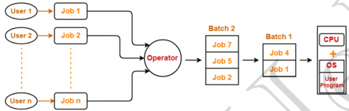

1. **Multi-Programming OS**

Multiprogramming Operating Systems can be simply illustrated as more than one program is present in the main memory and any one of them can be kept in execution. This is basically used for better execution of resources.

* Single CPU
* Context switching between the processes
* Switch happens when current process goes to wait state
* CPU idle time is reduced

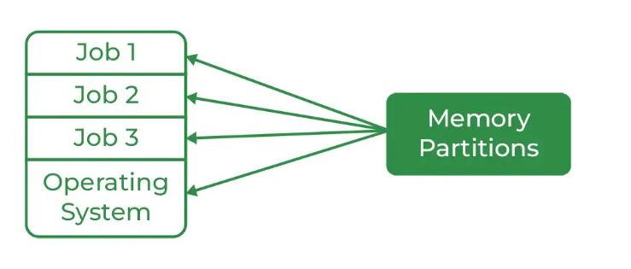

1. **Multitasking OS**

Multitasking Operating System is simply a multiprogramming Operating System with having facility of a Round-Robin Scheduling Algorithm. It can run multiple programs simultaneously.

* Single CPU
* Able to run more than one task simultaneously
* Context switching and time sharing used

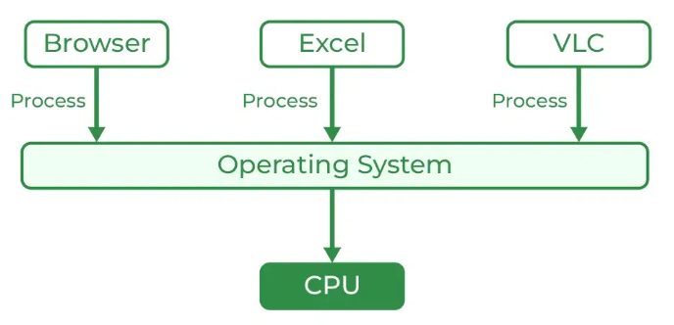

1. **Multi-Processing OS**

Multi-Processing Operating System is a type of Operating System in which more than one CPU is used for the execution of resources. It betters the throughput of the System.

* Increase Reliability, if one CPU fails, other can handle execution
* Lesser process starvation, if one CPU is working on some process, other can be executed in other CPU.
* Happens in multi-core processor

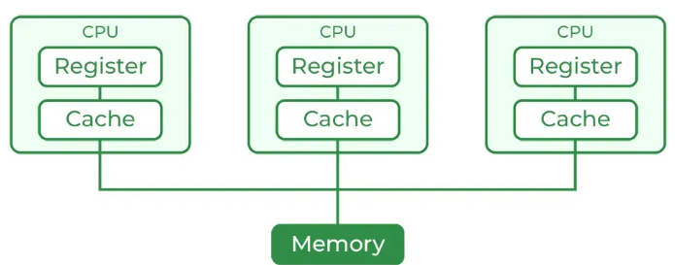

1. **Distributed OS**

Various autonomous interconnected computers communicate with each other using a shared communication network. Independent systems possess their own memory unit and CPU. These are referred to as loosely coupled systems or distributed systems. These systems’ processors differ in size and function. The major benefit of working with these types of the operating system is that it is always possible that one user can access the files or software which are not actually present on his system but some other system connected within this network i.e., remote access is enabled within the devices connected in that network.

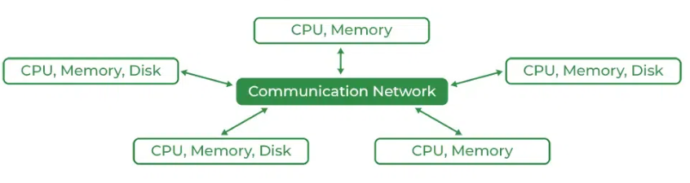

1. **Real-time Operating System**

These types of OSs serve real-time systems. The time interval required to process and respond to inputs is very small. This time interval is called response time. Real-time systems are used when there are time requirements that are very strict like missile systems, air traffic control systems, robots, etc.